**OBJECT ORIENTED PROGRAMMING LAB**

**ASSIGNMENT:** 6 **DATE:** 04-04-2023

**SLOT:** L3+L4 **MAX MARKS:** 10

**NAME:** K.KAVYANJALI **REGNO:**22BCE9513

1. Write a Java Program to implement Wrapper classes and their methods (include at least 10 methods).

**INPUT:**

**Boxing and Unboxing:**

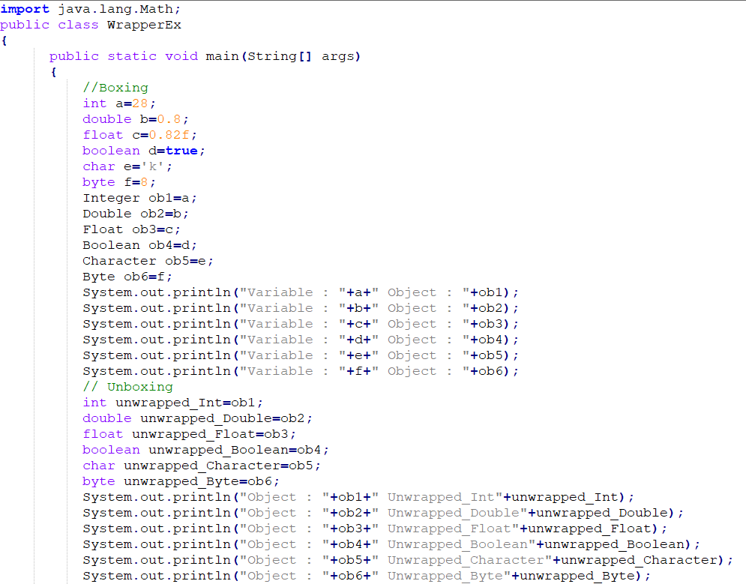

**Methods: :**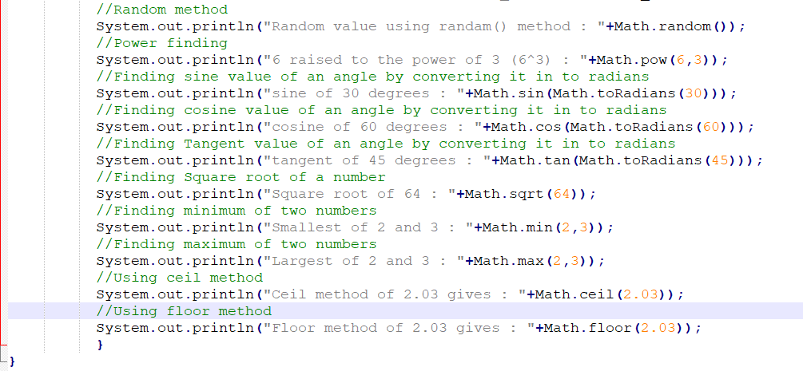

**OUTPUT:**

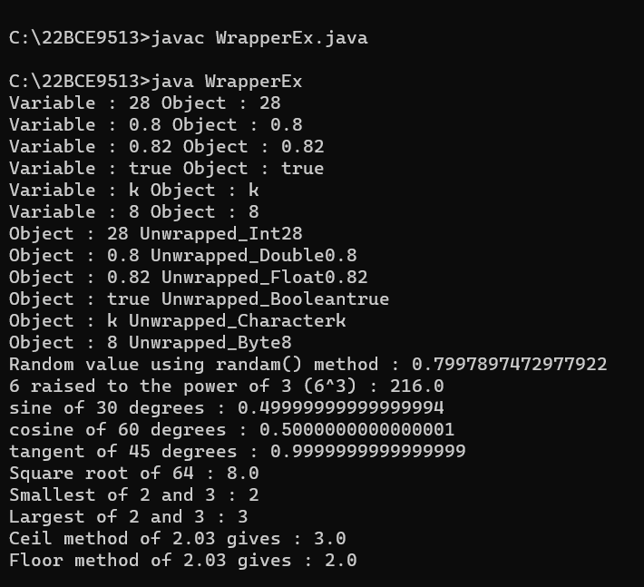

1. Write a Java program that prints all real solutions to the quadratic equation ax2+bx+c = 0. Read in a, b, c and use the quadratic formula. If the discriminate b2-4ac is negative, display a message stating that there are no real solutions.

**INPUT:**

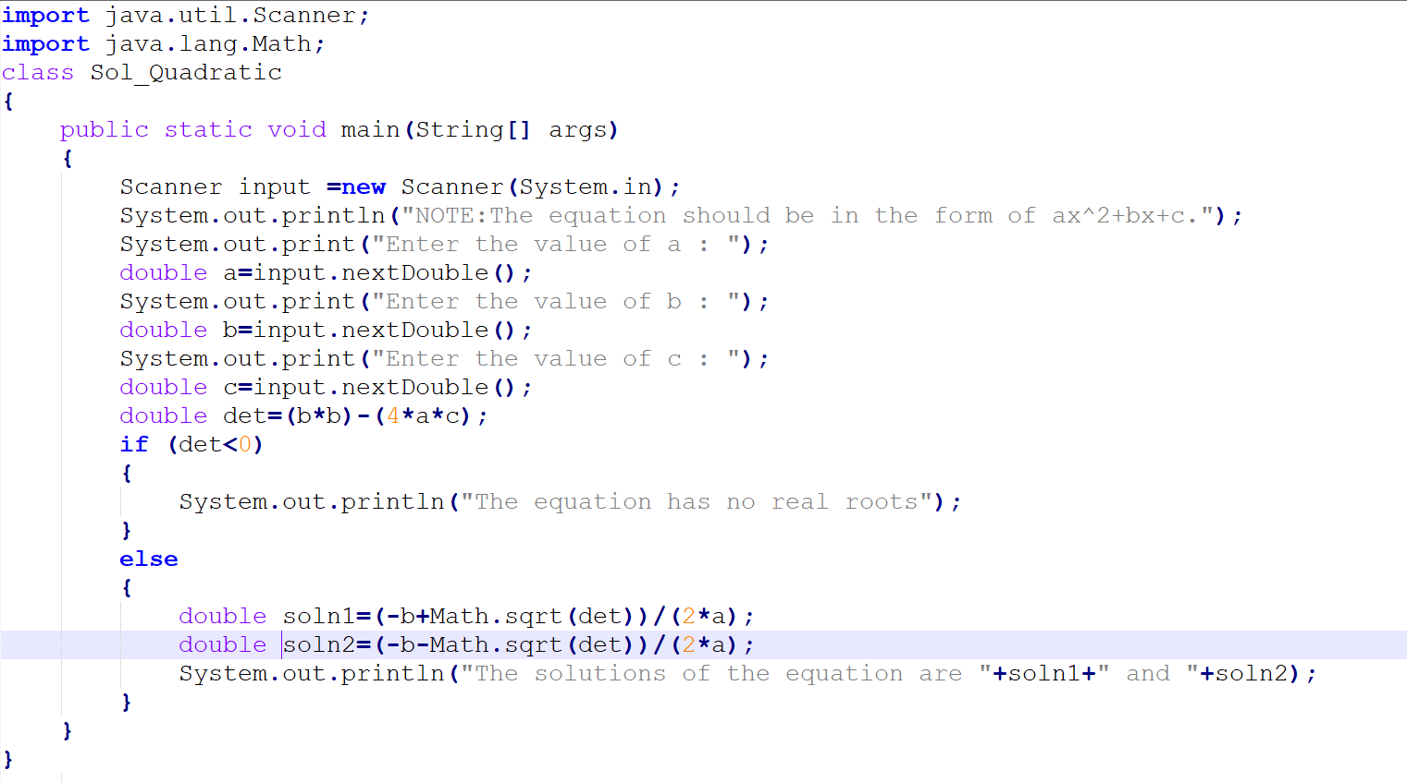

**OUTPUT:**

